**Practical No: 2A**

**Aim: Use CrypTool to encrypt and decrypt passwords using RC4 algorithm**

Write the text you want to encrypt. Go to Encrypt/Decrypt-> click on RC4 ->

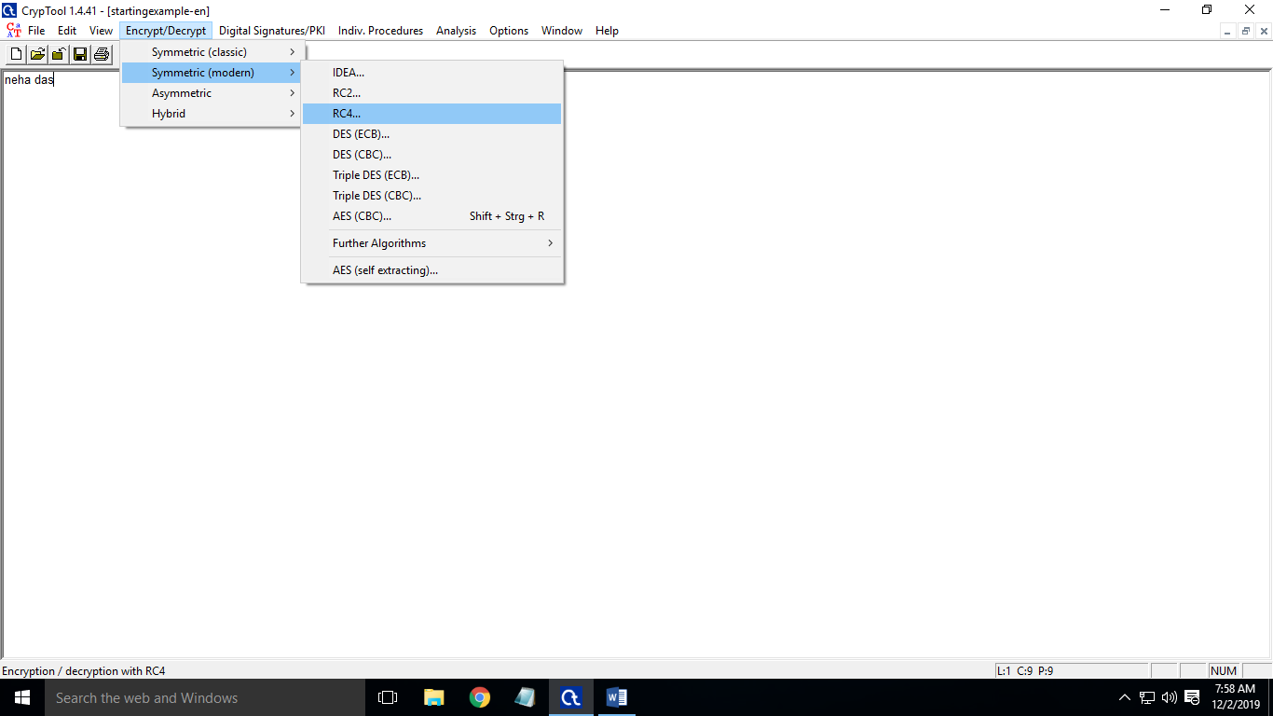

Click on encrypt

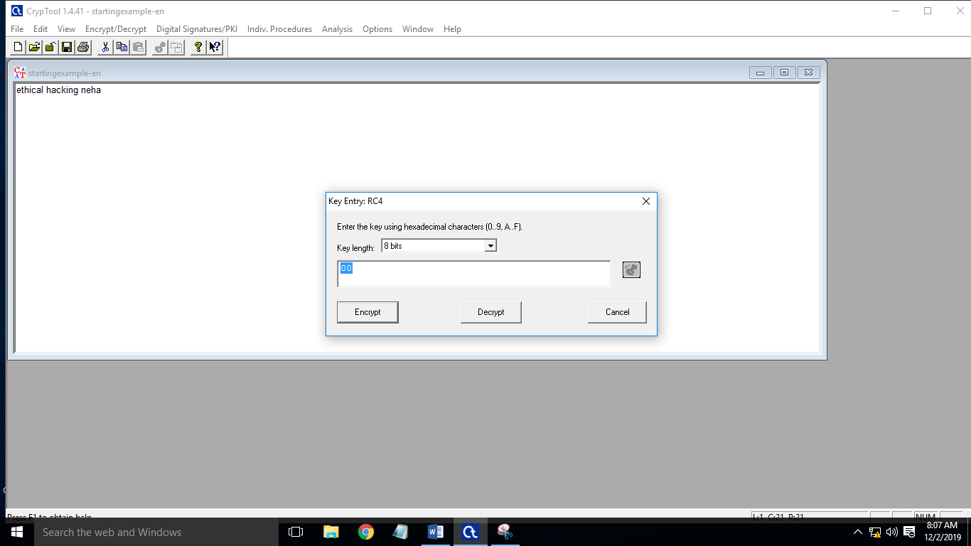

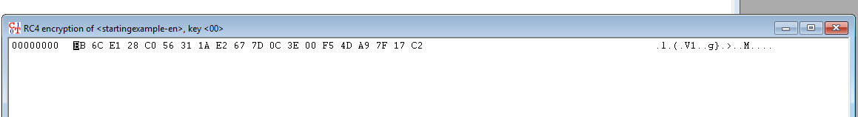

Click on decrypt



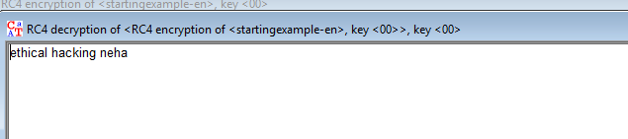

MD5

Write the text you want to encrypt. Go to indiviual Procedures -> Hash -> MD5

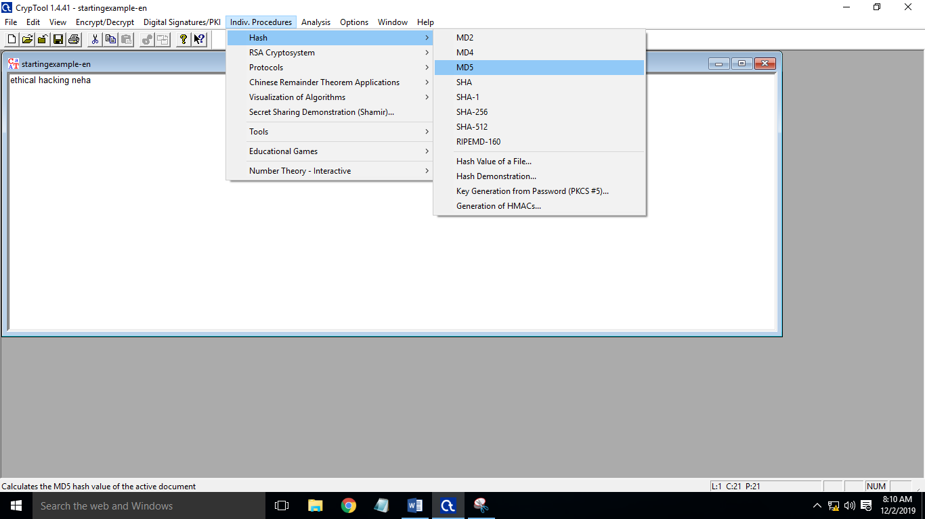

Hash value

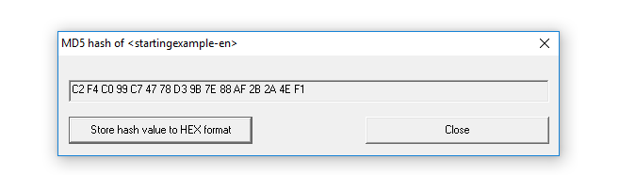

Click on store has value to HEX format

